# Yeast and Dissolved Oxygen in Water

|  |  |
| --- | --- |
| Biology: Cellular respiration | *DataStudio* GLX setup file: **yeast.glx** |

|  |  |  |
| --- | --- | --- |
| **Qty** | **Equipment and Materials** | **Part Number** |
| 1 | PASPORT Xplorer GLX | PS-2002 |
| 1 | PASPORT Dissolved Oxygen Sensor | PS-2108 |
| 1 | PASPORT Fast-Response Temperature Probe (included with GLX) | PS-2135 |
| 1 | Balance | SE-8723 |
| 1 | Beaker, 1 L (optional) | SE-7288 |
| 1 | Beaker. 250 mL |  |
| 1 | Graduated cylinder | SE-7289 |
| 1 | Hot plate (optional) | SE-8767 |
| 1 L | Ice, crushed or cube (optional) |  |
| 1 | Stir rod |  |
| 5 g | Sugar |  |
| 15 mL | Yeast suspension |  |
| 1 L | Water |  |
| 3 | Weighing paper |  |

## Purpose

The purpose of the activity is to explore the respiration rate of yeast in a dilute sugar-water solution. Measure the concentration of dissolved oxygen in the sugar-water solution before and after a small amount of yeast suspension is added to it.

## Background

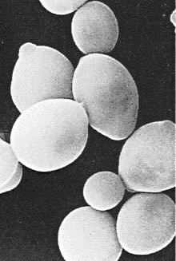During cellular respiration, organisms break apart carbohydrates to release energy. There are two types of cellular respiration – anaerobic and aerobic. Both types begin with glycolysis in which glucose is converted to pyruvic acid (pyruvate). In aerobic respiration, the byproducts include energy, water, and carbon dioxide gas. In anaerobic respiration, the byproducts include ethanol.



Yeasts are versatile organisms that can obtain their cellular energy either through aerobic respiration (requiring gaseous oxygen) or through anaerobic respiration – fermentation – (requiring the absence of oxygen). Yeast cells respire in either condition. The amount of cellular respiration depends on the availability of gaseous oxygen.

## Pre-lab Questions

Measure the dissolved oxygen concentration in a dilute sugar-water solution when a yeast suspension is added.

1. Aerobic cellular respiration requires oxygen. If yeast in a dilute sugar-water solution undergoe aerobic cellular respiration, what will happen to the concentration of oxygen in the solution?
2. Yeast are ectotherms whose metabolism is determined in part by the temperature of their surroundings. What will happen to the rate of respiration of yeast in the sugar-water solution if the temperature changes?

## Safety Precautions

Follow all directions for using the equipment.

Wear protective gear (e.g., safety goggles, gloves, apron).

## Procedure

### ::::::Public:Drop Box:Connect DO Sensor.tifGLX Setup

1. Plug the end of the Dissolved Oxygen probe cable into the connector on the top of the PASPORT Dissolved Oxygen Sensor.
2. Open the GLX setup file labeled **yeast.glx** (check the appendix at the end of this activity). The file is set so the sensor will measure 2 times per second. The file has two graphs: one for Dissolved Oxygen (mg/L) versus Time (s) and one for Temperature (˚C) versus Time (s).
3. Connect the Dissolved Oxygen Sensor into Port 1 on the top of the Xplorer GLX.

Figure 1: Connect sensor to GLX

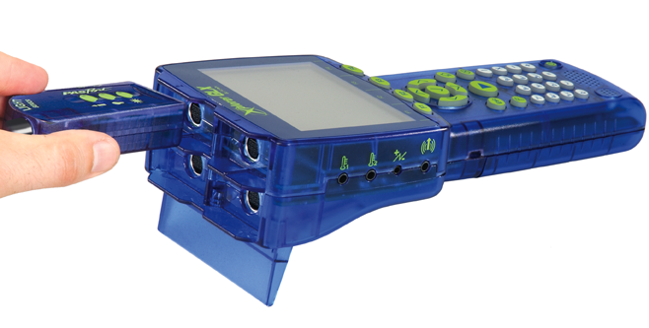

The Graph Screen will automatically open with Dissolved Oxygen (mg/L) versus Time (s).

1. Plug a PASPORT Fast-Response Temperature Probe into Port 1  on the left side of the GLX.

### Sensor Calibration (Optional)

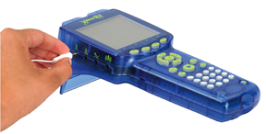

Figure 2: Connect probe to GLX

See the appendix at the end of this activity.

### Equipment Setup

1. Put 100 mL of warm (but not hot) water into a beaker.
2. Add 5 g of sugar to the water and mix it until it dissolves in the water.
3. Stir the water vigorously to saturate it with air.
4. Place the end of the Dissolved Oxygen probe into the sugar-water solution. Gently stir the solution with the probe.
5. Put the end of the Temperature Probe into the sugar-water solution.

### Record Data

1. Press the Start key :::GLX Graphics:GLX icons buttons:Green Buttons:Start.tif on the GLX.

**Figure 3: Add yeast**

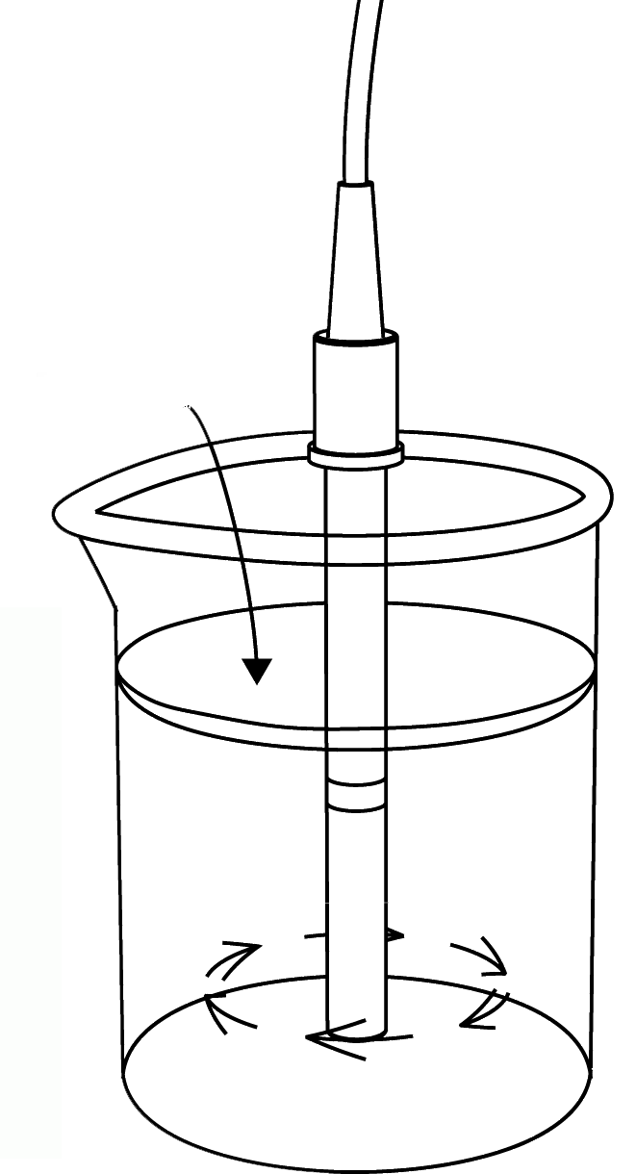

1. After 30 seconds, put 15 mL of activated yeast suspension into the sugar-water solution.
2. Continue to gently stir with the probe and record data for about 10 minutes (or until the oxygen level stabilizes). Write a description of what happens in the solution.
3. Stop recording data. Remove the probes from the solution and carefully rinse the probes. Dispose of the contents of the beaker as directed and rinse the beaker.

### Record Data: Cold Temperature

1. Repeat the procedure to set up the sugar-water solution.

Put 100 mL of warm (but not hot) water into the beaker. Add 5 g of sugar to the water and mix it until it dissolves in the water. Stir the water vigorously to saturate it with air.

1. Place the beaker with the sugar-water solution inside a large beaker. Put crushed or cube ice into the larger beaker up to the level of the smaller beaker. Add some water to the ice.
2. Wait a few minutes while the sugar-water solution cools down.
3. Put the Dissolved Oxygen probe into the sugar-water solution. Gently stir the solution with the probe. Put the Temperature Probe into the solution.
4. Press the Start key :::GLX Graphics:GLX icons buttons:Green Buttons:Start.tif on the GLX.
5. After 30 seconds, put 15 mL of activated yeast suspension into the sugar-water solution.
6. Continue to gently stir with the probe and record data for about 10 minutes (or until the oxygen level stabilizes). Write a description of what happens in the solution.
7. Stop recording data. Remove the probes from the solution and carefully rinse the probes. Dispose of the contents of the beaker as directed and rinse the beaker.

### Record Data: Hot Temperature

1. Repeat the procedure to set up the sugar-water solution.

Put 100 mL of warm (but not hot) water into the beaker. Add 5 g of sugar to the water and mix it until it dissolves in the water. Stir the water vigorously to saturate it with air.

1. Place the beaker with the sugar-water solution on a hot plate and turn on the hot plate.
2. Wait a few minutes while the sugar-water solution warms up.
3. Put the Dissolved Oxygen probe into the sugar-water solution. Gently stir the solution with the probe. Put the Temperature Probe into the solution.
4. Press the Start key :::GLX Graphics:GLX icons buttons:Green Buttons:Start.tif on the GLX.
5. After 30 seconds, put 15 mL of activated yeast suspension into the sugar-water solution.
6. Continue to gently stir with the probe and record data for about 10 minutes (or until the oxygen level stabilizes). NOTE: Do not let the sugar-water solution begin to boil! Write a description of what happens in the solution.
7. Stop recording data. Turn off the hot plate.
8. Remove the probes from the solution and carefully rinse the probes. Dispose of the contents of the beaker as directed and rinse the beaker.

## Analysis

1. Draw a sketch of your Dissolved Oxygen versus Time graph as requested in the Lab Report section.
2. Use your recorded data to find the *change* *in dissolved oxygen* for the sugar-water solution and yeast for each run of data you recorded.

In the Graph Screen, press *F3* to open the ‘Tools’ menu. Select ‘Statistics’ and press ‘Activate’. The Statistics show the minimum and maximum values.

1. Determine the initial and final temperature for each run of data you recorded.

In the Graph Screen, press *F4* to open the ‘Graphs’ menu. Use the up-down cursor keys to select ‘Graph 2’ and press ‘Activate’ to show the graph of Temperature (˚C) versus Time.

How do your results compare with others in your class?

### Record your results in the Lab Report.

## ------------------------

## Appendix:

To open a specific GLX file, go to the home screen (press :::GLX Graphics:Icons buttons:Green Buttons:Home.tif). In the home screen, select ‘Data Files’ and press ‘Activate’ (:::GLX Graphics:Icons buttons:Green Buttons:Check.tif). Use the cursor keys to navigate to the file you want. Press *F1* (:::GLX Graphics:Icons buttons:Green Buttons:F1.tif) to open the file.



Data Files Icon

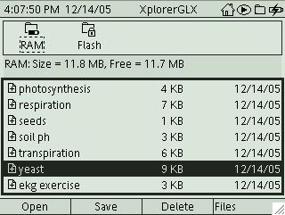

Optional: To calibrate the PS-2108 Dissolved Oxygen Sensor, see the instructions provided by the instructor.

# Lab Report - Activity 04: Yeast and Dissolved Oxygen in Water

## Name ________________________________ Date ___________

## Pre-Lab Questions

Measure the dissolved oxygen concentration in a dilute sugar-water solution when a yeast suspension is added.

1. Aerobic cellular respiration requires oxygen. If yeast in a dilute sugar-water solution break down the sugar during aerobic cellular respiration, what will happen to the concentration of oxygen in the solution?
2. Yeast are ectotherms whose metabolism is determined in part by the temperature of their surroundings. What will happen to the rate of respiration of yeast in the sugar-water solution if the temperature changes?

## Data

Make a sketch of one run of Dissolved Oxygen Concentration versus Time, including labels for the y- and x-axes. Label the section of the graph that shows aerobic cellular respiration and the section of the graph that shows anaerobic cellular respiration.

## ::07 Resources:Blank graph.tif

### Data

Write a description of what happened in the sugar-water solution during each run:

1. Normal temperature:
2. Cold temperature:
3. Hot temperature:

### Data Table

|  |  |  |  |  |
| --- | --- | --- | --- | --- |
| **Run** | **Maximum O2 (mg/L)** | **Minimum O2 (mg/L)** | **Initial Temp.** | **Final Temp.** |
| Yeast (normal temperature) |  |  |  |  |
| Yeast (cold temperature) |  |  |  |  |
| Yeast (hot temperature) |  |  |  |  |

## Questions

1. What happens to the level of dissolved oxygen in the sugar-water solution in each of the trials?
2. Based on your observation of the sugar-solution in run #1, at about what time do you think fermentation began?
3. How did the hot temperature affect the yeast?